UCS415 – Design and Analysis of Algorithms Lab Assignment 3

**Name: Akshita Pathak**

**Roll No: 102203796**

**Subgroup: 2CO18**

**Write a program to implement the following using dynamic programming approach:**

* **Longest Common Subsequence**

/*

1. Longest Common Subsequence

*/

#include<iostream>

using namespace std;

int main()

{

string A="stone";

string B="longest";

int m=A.length();

int n=B.length();

int lcs[m+1][n+1];

for(int i=0;i<=m;i++){

for(int j=0;j<=n;j++){

if(i==0 || j==0 ){

lcs[i][j]=0;

}

else if(A[i-1]==B[j-1]){

lcs[i][j]=1+lcs[i-1][j-1];

}

else{

lcs[i][j]=max(lcs[i-1][j],lcs[i][j-1]);

}

}

}

cout<<"Length of longest common subsequennce is: "<<lcs[m][n]<<endl;

//op- 3 -- one

return 0;

}

**OUTPUT:**

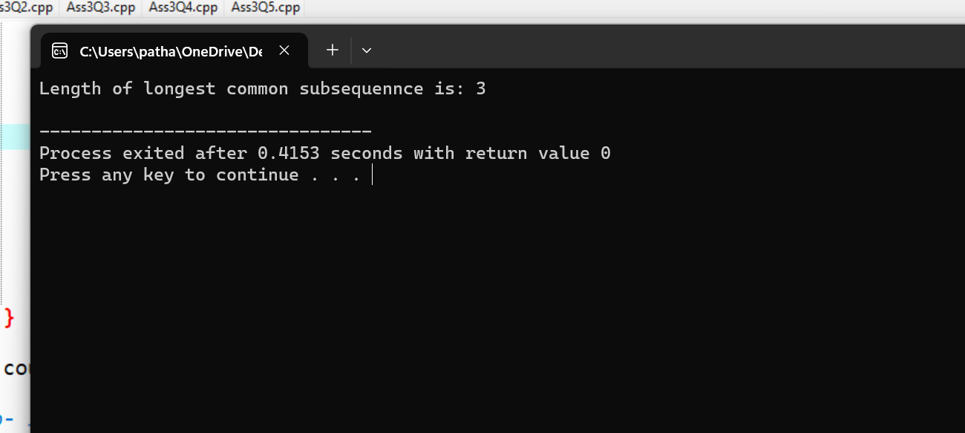

* **Matrix Chain Multiplication**

/*

2. Matrix Chain Multiplication

*/

#include<iostream>

using namespace std;

int main()

{

//no of matrices+1

int n=5;

//array to store dimensions of matrices

int d[]={5,4,6,2,7};

//take 2d arrays to store result

int c[5][5]={0};

int k[5][5]={0};

//take diff of j-1

for(int diff=1;diff<n-1;diff++){

//row

for(int i=1; i<n-diff;i++){

//clm

int j=i+diff;

int min=32767;

int cost;

//find minm

for(int K=i;K<j;K++){

cost=c[i][K]+c[K+1][j]+d[i-1]*d[K]*d[j];

if(cost<min){

min=cost;

k[i][j]=K;

}

}

c[i][j]=min;

}

}

cout<<"output- "<<c[1][n-1];

return 0;

}

//op- 158

**OUTPUT:**

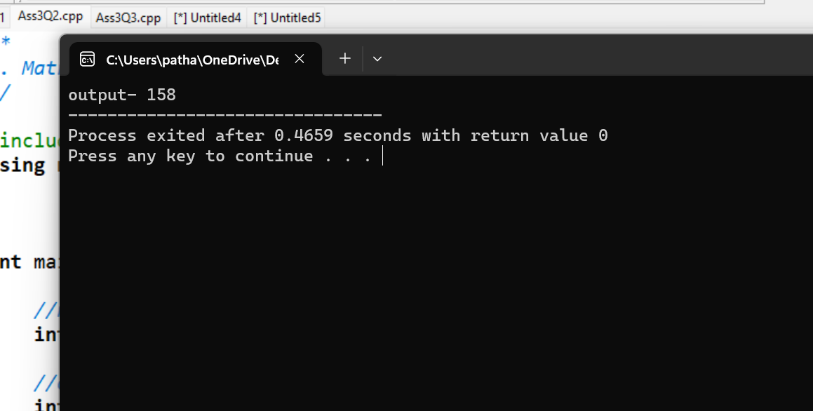

* **0/1 Knapsack Problem**

/*

3. 0/1 Knapsack Problem

*/

#include<iostream>

using namespace std;

int main()

{

//array of profits

int p[5]={0,2,4,7,10};

//0 index just added

//array of weights of objects

int wt[5]={0,1,3,5,7};

//knapsack capacity M

int M=8;

//no of objects

int n=4;

//2d array table where row-objects(n+1) and clm-capacity(M+1)

int k[5][9];

//i row

for(int i=0;i<=n;i++){

//w clm

for(int w=0;w<=M;w++){

//for all 0 indices- profit is 0

if(i==0 || w==0){

k[i][w]=0;

}

//if weight of object is less than capacity

else if(wt[i]<=w){

k[i][w]=max(k[i-1][w],k[i-1][w-wt[i]]+p[i]);

}

else{

k[i][w]=k[i-1][w];

//take upper value

}

}

}

cout<<"Total profit= "<<k[n][M]<<endl;

//to know which obj is included or not-

int i=n;

int j=M;

while(i>0 && j>0){

//if that value is present in above row also then dont include it

if(k[i][j]==k[i-1][j]){

cout<<i<<"=0 ie not included \n";

i--;

}

else{

cout<<i<<"=1 ie included \n";

i--;

j=j-wt[i]; //check weight after subtracting

}

}

//op- 12 and included- 1001

return 0;

}

**OUTPUT:**

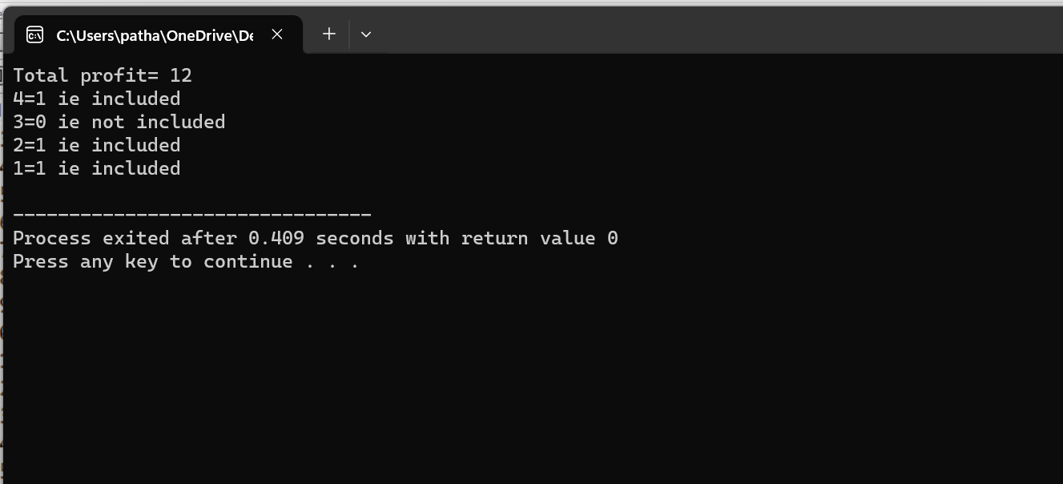

* **Optimal Binary Search Tree**

/*

4. Optimal Binary Search Tree

*/

#include<iostream>

using namespace std;

// Function to calculate optimal binary search tree

void obst(int n, int *keys, int *p, int **c, int **r) {

for (int i = 0; i <= n + 1; i++) {

c[i] = new int[n + 1]();

}

for (int i = 0; i <= n; i++) {

r[i] = new int[n + 1]();

}

for (int i = 1; i <= n; i++) {

c[i][i - 1] = 0;

c[i][i] = p[i - 1];

r[i][i] = i;

}

c[n + 1][n] = 0;

for (int d = 1; d < n; d++) {

for (int i = 1; i <= n - d; i++) {

int j = d + i;

int min = INT_MAX;

for (int R = i; R <= j; R++) {

int cost = c[i][R - 1] + c[R + 1][j];

if (cost < min) {

min = cost;

r[i][j] = R;

}

}

c[i][j] = min + p[j - 1] + p[i - 1];

}

}

}

int main() {

// n- no of keys

// p- probability of searching key

int n = 4;

int keys[] = {10, 20, 30, 40};

int p[] = {4, 2, 6, 3};

int **c = new int*[n + 2];

int **r = new int*[n + 1];

obst(n, keys, p, c, r);

cout << "Cost Table: " << endl;

for (int i = 1; i <= n + 1; i++) {

for (int j = 0; j <= n; j++) {

cout << c[i][j] << " ";

}

cout << endl;

}

cout << "\nRoot Table:" << endl;

for (int i = 1; i <= n; i++) {

for (int j = 1; j <= n; j++) {

cout << r[i][j] << " ";

}

cout << endl;

}

cout << "Minimum Cost of Optimal Binary Search Tree: " << c[1][n] << endl;

return 0;

}

**OUTPUT:**

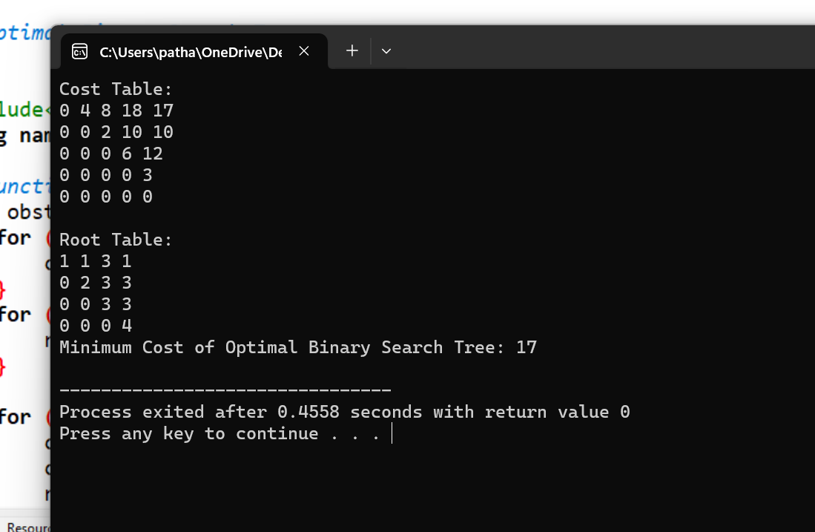

* **Coin Exchange Problem**

/*

5. Coin Exchange Problem

*/

#include<iostream>

#include<algorithm>

using namespace std;

int min(int a,int b){

return a<b? a:b;

}

void no_of_coins(int coins[],int w,int n){

int i; //coins array

int j; //amount into subproblems

int a[n+1][w+1];

for(i=0;i<=n;i++){

for(j=0;j<=w;j++){

a[i][j]=INT_MAX; //initialise array to 0

}

}

for(i=0;i<=n;i++){

a[i][0]=0; //for 0 amount we require no coins so op=0

}

for(j=1;j<=w;j++){

a[0][j]=INT_MAX; //if no coins available then no amount can be formed

}

for(i=1;i<=n;i++){

for(j=1;j<=w;j++){

//for case1 when coin>w

if(coins[i-1]>j){

//copy value from above row

a[i][j]=a[i-1][j];

}

else{

a[i][j]=min(a[i-1][j],1+a[i][j-coins[i-1]]);

}

}

}

cout<<endl<<"Printing array "<<endl;

for(int i=0;i<=n;i++){

for(int j=0;j<=w;j++){

cout<<a[i][j]<<" ";

}

cout<<endl;

}

cout<<endl<<"The minimum no of coins reqd to make sum of "<<w<<" is: "<<a[n][w]<<endl;

//to find denomination::

cout<<"The denomination of coins reqd to make sum "<<w<<" is: "<<endl;

i=n;

j=w;

while(i>0 && j>0){

if(a[i][j]!=a[i-1][j]){

cout<<"included coin no: "<<i<<" with denomination: "<<coins[i-1]<<endl;

j=j-coins[i-1];

}

else{

i--;

}

}

}

int main()

{

int n;

cout<<"Enter total no of coins u have: \n";

cin>>n;

// int n=4;

int coins[n];

for(int i=0;i<n;i++){

cout<<"Enter the coin no "<<i<<" : ";

cin>>coins[i];

}

// int coins[]={1,5,6,9};

int w;

cout<<"Enter total amount u want to make: \n";

cin>>w;

// int w=10;

no_of_coins(coins,w,n);

return 0;

}

**OUTPUT:**

